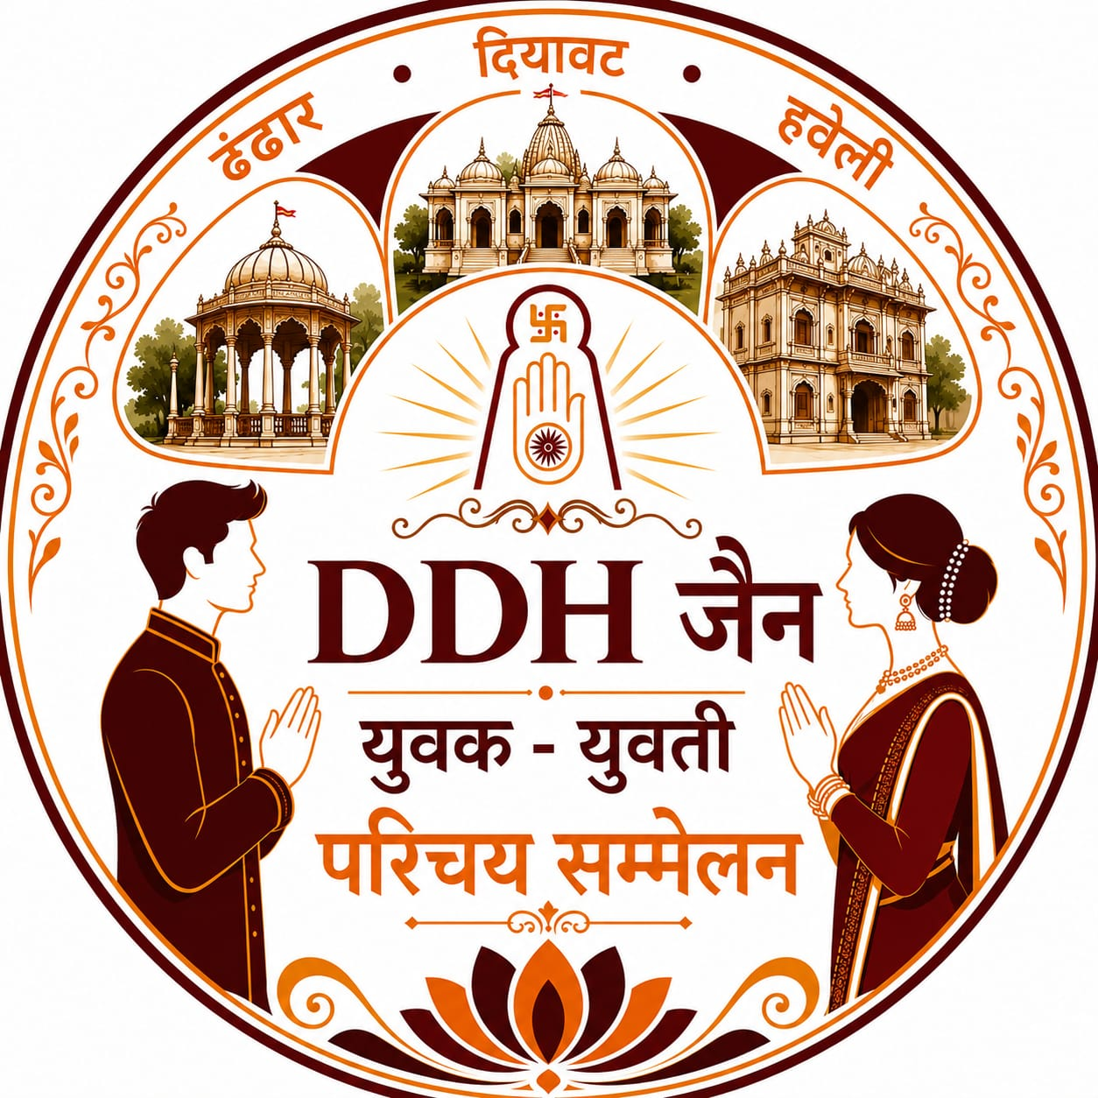 | ।। ॐ अर्हम नमः ।।  DDH Member's Detail  DDH जैन युवक - युवती परिचय सम्मेलन

- DHANDHAR (DHA)  - DIYAWAT (DIY)  - HAVELI (HAV)  - OTHER SAMAJ HOTI No. |  | VILLAGE HOTI No.

FAMILY TITLE | NAME FATHER’S NAME GOTRA | NATIVE VILLAGE | CITY

MOBILE (1) |  | MOBILE (2)

OFFICE ADDRESS:

COMPANY NAME:

DOOR No. & STREET | SHOP No. & BLDG. No. | FLOOR | AREA

LOCATION | CITY | PINCODE | STATE | DIGIPIN

S.T.D. CODE | TELEPHONE (1) | TELE PHONE (2) | FAX

E-MAIL: | WEB SITE:

RESIDENCE ADDRESS

DOOR No. & STREET | FLAT No. & BLDG. No. | FLOOR | AREA

LOCATION | CITY | PINCODE | STATE | S.T.D.CODE & TELE No.

FAMILY DETAILS:
S. No. | NAME | RELATION | M / F | D.O.B | MOBILE | BLOOD GROUP | QUALIFICATION | D.O.M | SPOUSE GOTRA

TO FILL ONLINE FORMS CLICK FOLLOWING LINKS:

For Head of The Family Member Fill This Form:

Fill Different Form for Each Family Member.

Follow the DDH जैन युवक - युवती परिचय सम्मेलन channel on WhatsApp:

Contact : WhatsApp : 8779628190

FILL FORM IN CAPITAL LETTERS IN BLACK INK ONLY.

