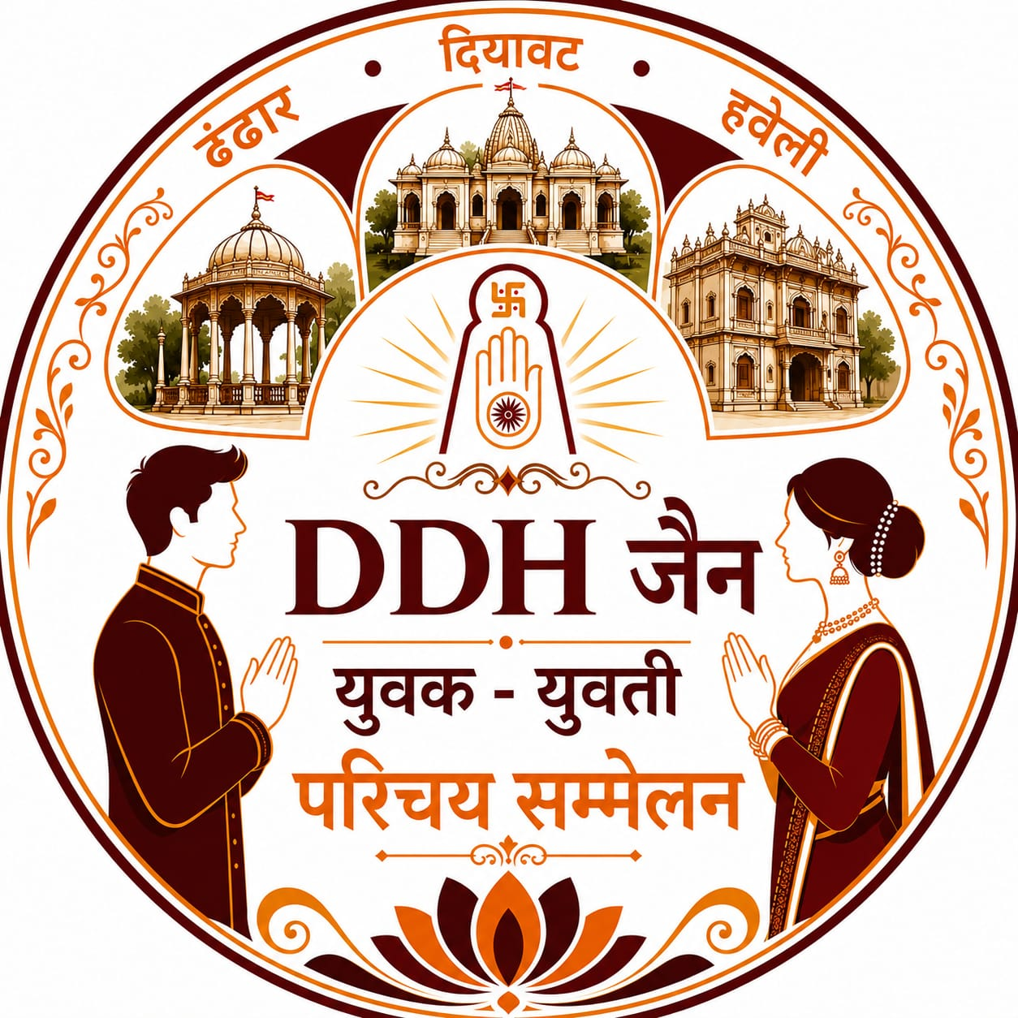 | ।। ॐ अर्हम नमः ।।  DDH जैन युवक - युवती परिचय सम्मेलन

MALE / FEMALE | ID NUMBER | STATE CODE

- DHANDHAR | - DIYAWAT | - HAVELI | - OTHER SAMAJ

FAMILY TITLE | NAME FATHER’S NAME GOTRA | NATIVE PLACE | CONTACT No.

DATE OF BIRTH |  | MARITAL STATUS |  | QUALIFICATIONS

OFFICE ADDRESS:

COMPANY NAME:

DOOR No. & STREET | SHOP No. & BLDG. No. | FLOOR | AREA

LOCATION | CITY | PINCODE | STATE | DIGIPIN

S. No. | RELATIVES NAME | NAME | FATHER'S NAME | GOTRA
1 | FATHER
2 | MOTHER
3 | DADA
4 | DADI
5 | NANA
6 | NANI

REQUIRED CHOICE

CITY | AGE | EDUCATION |  | WORKING / NON WORKING

FOR ONLINE REGISTRATION CLICK HERE:

Follow the DDH जैन युवक - युवती परिचय सम्मेलन channel on WhatsApp:

Contact : WhatsApp : 8779628190

FILL FORM IN CAPITAL LETTERS IN BLACK INK ONLY.

